1-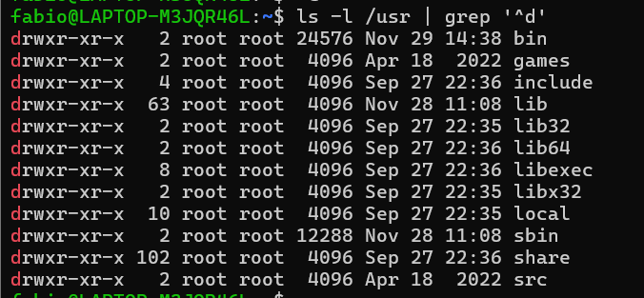

b)

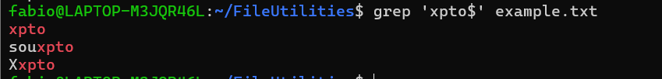

d)



3- a)

b) The $ symbol ensures that "Lebre" appears at the end of the name



c) 

d) 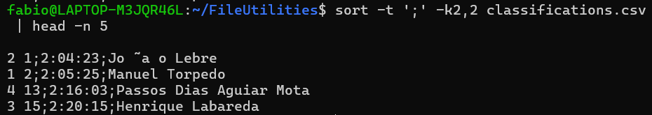

f) 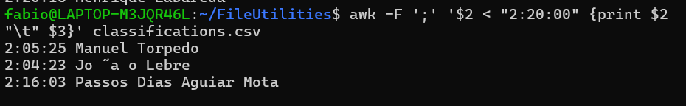

g) 

4-

1. The -n option in grep prints each matching line with its line number in the file.
2. The -B num option prints num lines of trailing context **before** each match.
3. The -A num option prints num lines of trailing context **after** each match.
4. The -C num option combines both -B and -A options, printing num lines of context **before** and **after** each match.
5. The -m num option causes grep to stop reading a file after finding num matching lines.
6. The -q option is useful when you only want to know whether a match exists or not, without displaying the matching lines. It returns a zero exit status if a match is found and a non-zero exit status if no match is found.
7. The -i option makes grep perform a case-insensitive search, so it will match both uppercase and lowercase characters.

5- grep -P "^\d{4}-\d{3}\s[A-Za-z0-9\s\.

6-grep -P "^\+351\s(\d{3}\s?\d{3}\s?\d{3}|\d{2}\s?\d{3}\s?\d{4}|\d{9})$" test_phone_numbers.txt

7-

1. **-name**: The -name option is case-sensitive when searching for files or directories by name. This means that if you specify a pattern, it will only match files that exactly match the pattern in terms of case.

**-iname**: The -iname option works the same way as -name, but **it is case-insensitive**. This means it will match files regardless of case.

1. **-mtime**: The -mtime option is used to find files based on the **last modification time**. It accepts the following format:

-mtime +n: Files modified **more than n days ago**.

-mtime -n: Files modified **less than n days ago**.

-mtime n: Files modified exactly **n days ago**.

**Creating periodic backups**: To create periodic backups, you could use the -mtime option to select files that were modified within a specific time range.

1. **-size**: The -size option is used to find files based on their size. You can use it in the following formats:

-size +n: Files that are **larger** than n units.

-size -n: Files that are **smaller** than n units.

-size n: Files that are exactly n units in size.

The size units can be specified as:

b for 512-byte blocks (default).

k for kilobytes.

M for megabytes.

G for gigabytes, etc.

1. **Regular file identifier**: The identifier for a regular file is **-type f**. This option selects only regular files (not directories, symbolic links, or other special file types).

**Directory identifier**: The identifier for a directory is **-type d**. This option selects directories (not regular files, symbolic links, etc.).

8-

Yes, the find command in this case will only search **within the /bin directory** and its **subdirectories** (recursively). The search will not extend to other directories outside /bin.

11-

12 –

b)



13-  


14-

